

PROJECT REPORT
Impact of Potholes on Traffic Flow

By- Gaurav Chhabra(24csu249)

1. Abstract
Road surface conditions significantly influence traffic flow, vehicle safety, and congestion patterns. This project presents an AI-based system that detects potholes from road images and videos using YOLOv8 object detection and calculates a Road Quality Index (RQI). Based on the detected damage, the system estimates congestion risk. The application is implemented with a professional GUI dashboard using Tkinter and supports both image and video analysis. This system demonstrates how computer vision can assist in smart traffic management and infrastructure monitoring.
2. Introduction
Poor road conditions, especially potholes, cause:
- Reduced vehicle speed
- Increased traffic congestion
- Higher accident risk
- Vehicle damage
- Increased fuel consumption
Traditional road inspection methods are manual and inefficient. This project proposes an automated AI-based solution to:
- Detect potholes
- Calculate road quality
- Predict congestion levels
3. Problem Statement
To analyze how potholes and road surface damage affect traffic flow by:
- Detecting potholes from images/videos
- Calculating Road Quality Index (RQI)
- Classifying road condition
- Predicting congestion risk
4. Objectives
The main objectives of this project are:
- Detect potholes using YOLOv8 model
- Calculate Road Quality Index (RQI)
- Classify road condition (Good / Moderate / Poor)
- Predict congestion risk
5. Technologies Used
Python | Programming language
YOLOv8 | Object detection model
OpenCV | Image & video processing
Tkinter | GUI development
PIL | Image handling
NumPy | Mathematical calculations
6. Steps for Analysing Road Conditions
Step 1: Data Input
- User uploads image or video of road surface.
Step 2: Pothole Detection
- YOLOv8 detects potholes using trained weights (best.pt).
- Bounding boxes are drawn around potholes.
Step 3: Road Quality Index Calculation
RQI is calculated using:
$$RQI=1-\frac{DamagedArea}{TotalRoadArea}$$
Where:
- Damaged Area = Sum of all pothole bounding box areas
- Total Road Area = Total frame size
RQI range:
- 0 → Very Poor
- 1 → Excellent
Step 4: Road Condition Classification
RQI Value | Road Condition | Congestion Risk
0.80 – 1.0 | Good | Low
0.50 – 0.79 | Moderate | Medium
0.00 – 0.49 | Poor | High

7. System Architecture
- User Interface (Tkinter Dashboard)
- Image/Video Upload Module
- YOLO Detection Module
- RQI Calculation Module
- Traffic Impact Analysis Module
- Result Display Module
8. Features of the Dashboard
- Image upload
- Video upload
- Real-time detection
- Pothole count display
- RQI display
- Road condition display
- Congestion prediction
9. Sample Output
For an example road:
- Potholes Detected: 6
- RQI: 0.62
- Road Condition: Moderate
- Congestion Risk: Medium
10. Results & Observations
- Higher number of potholes → Lower RQI
- Lower RQI → Reduced traffic speed
- Reduced speed → Increased congestion probability
- AI detection significantly speeds up road monitoring
The system successfully demonstrates a direct relationship between road damage and traffic flow efficiency.

- ANALYSIS GRAPHS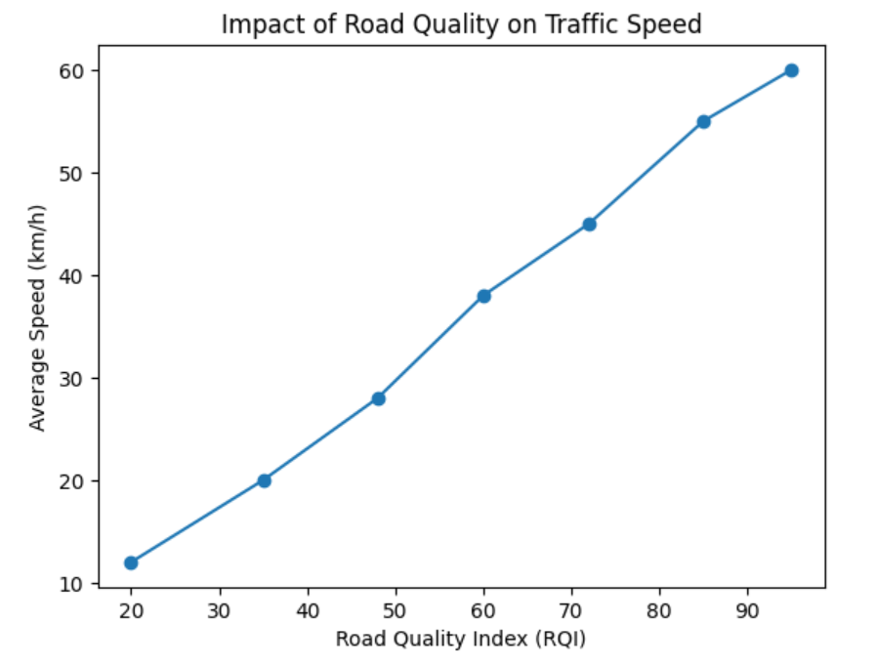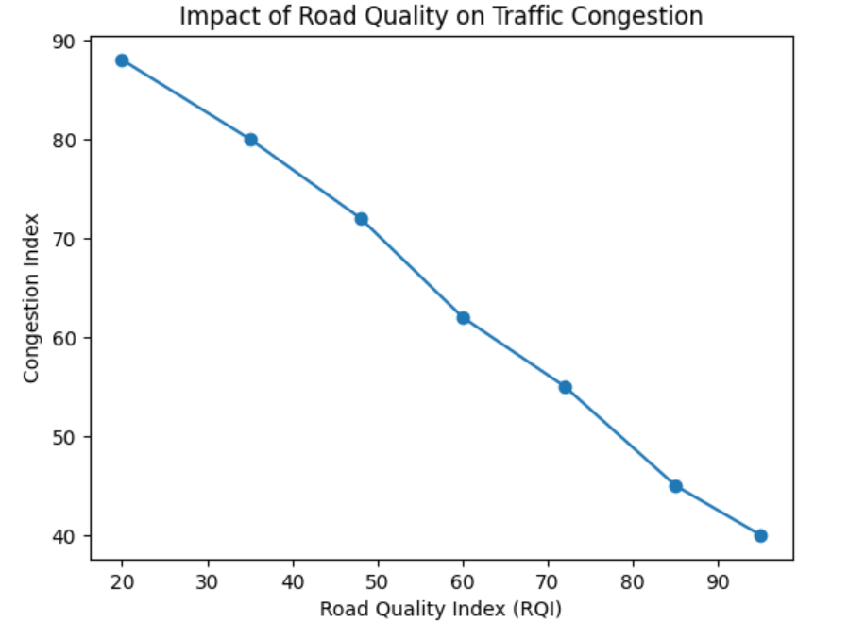

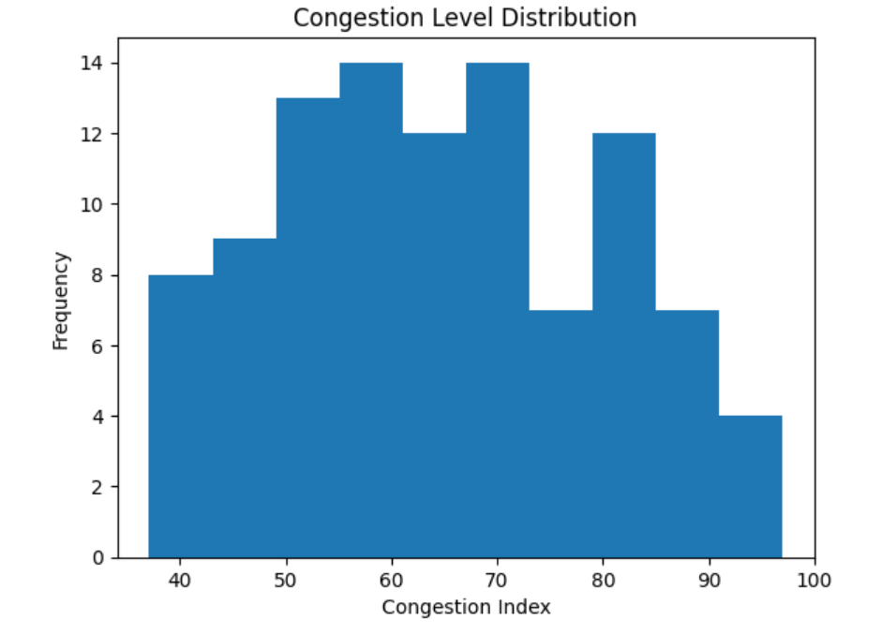
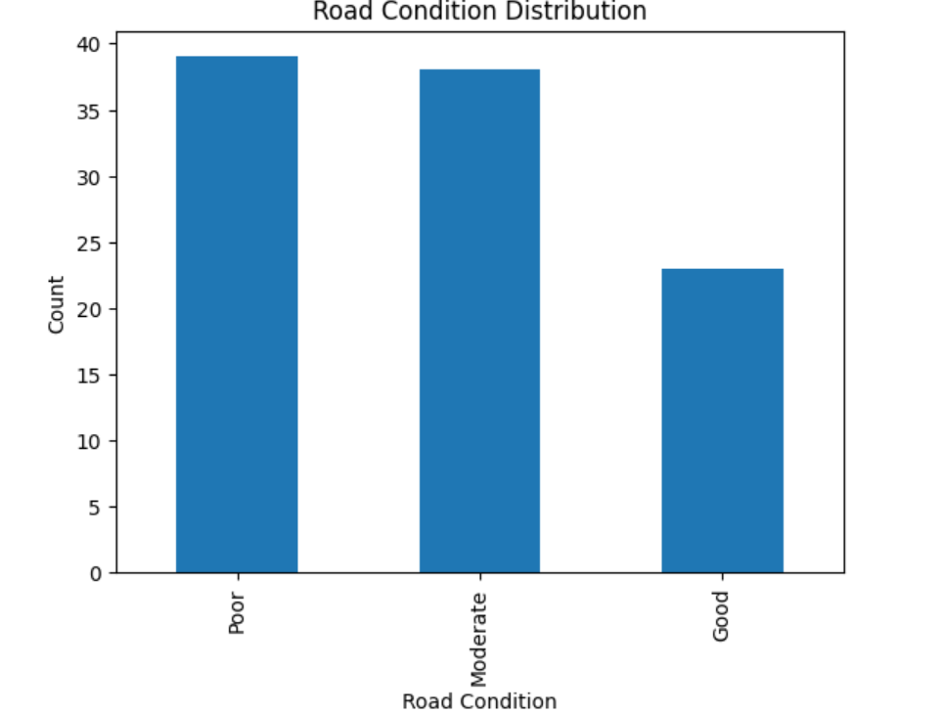
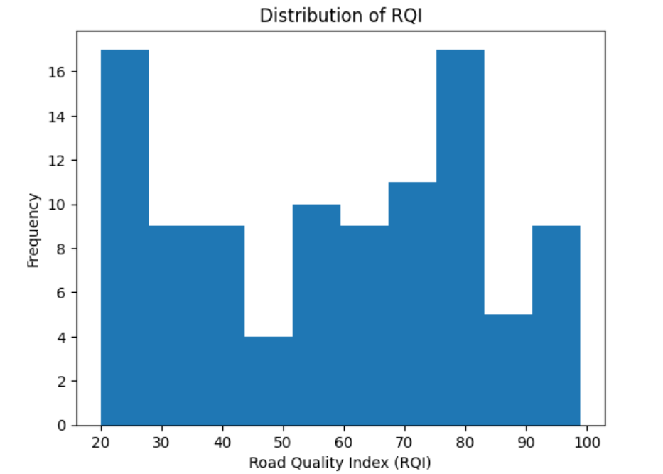
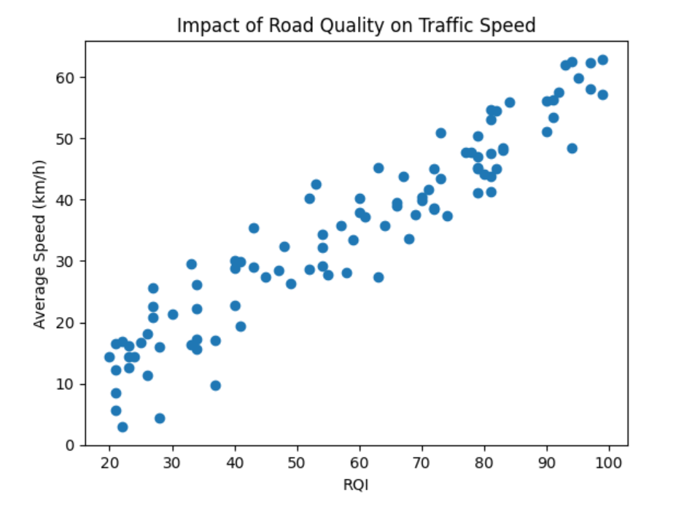
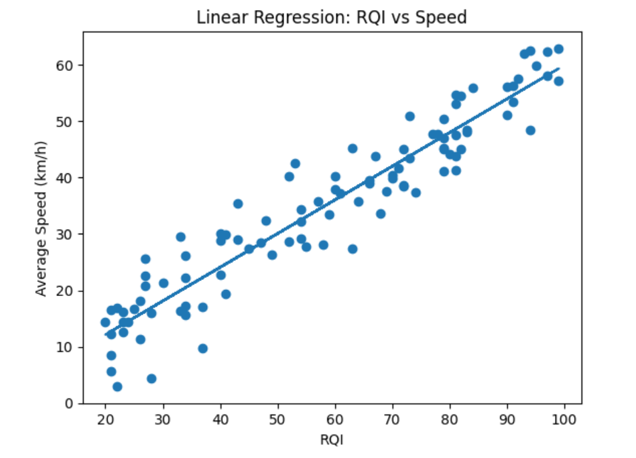

- ROAD IMAGES AFTER MODEL TRAINING
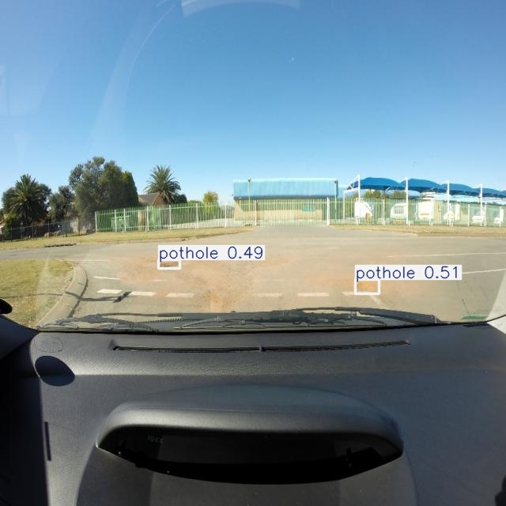
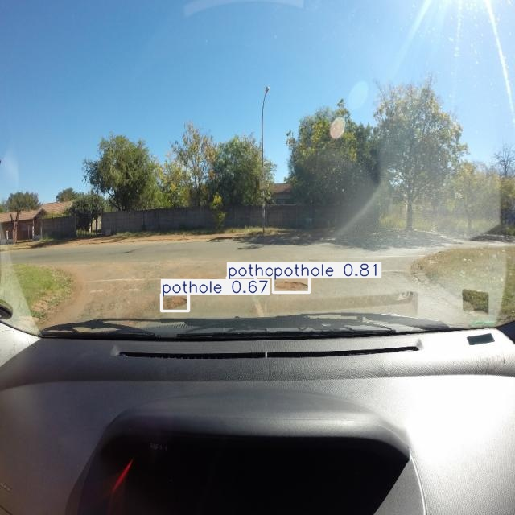

- EXAMPLE OUTPUT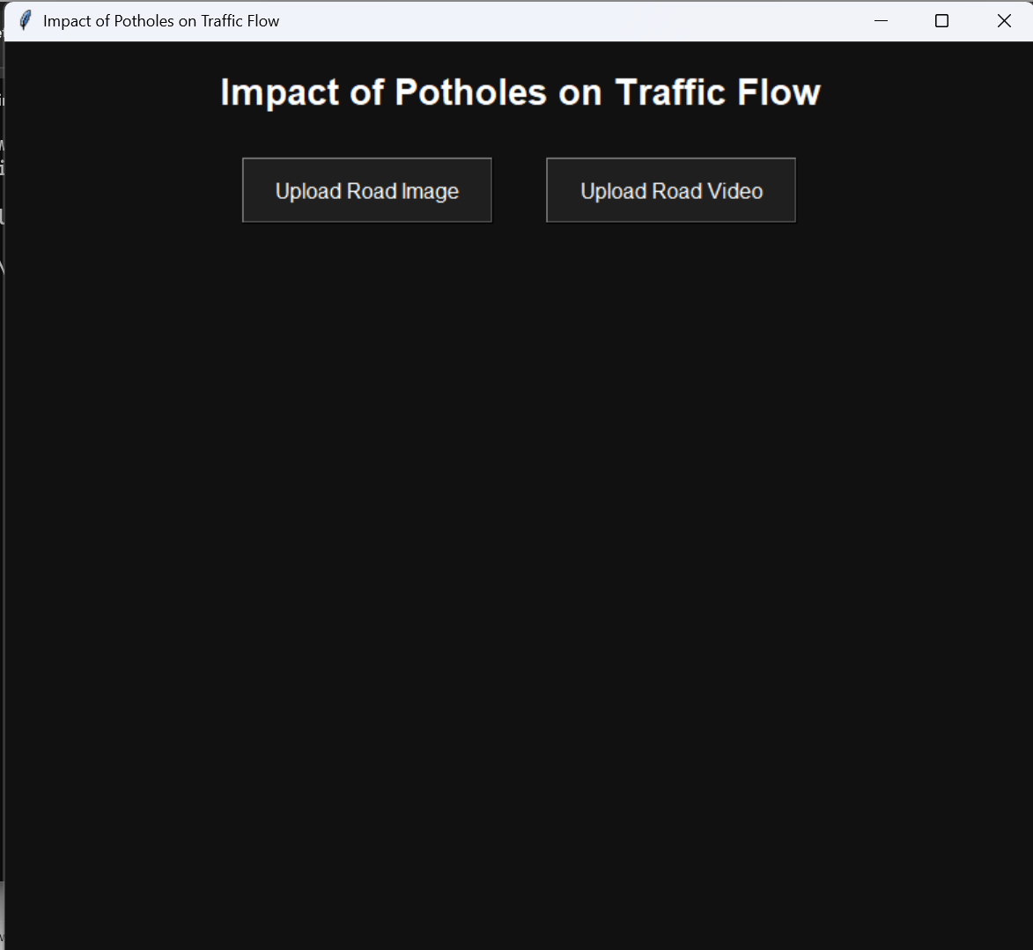

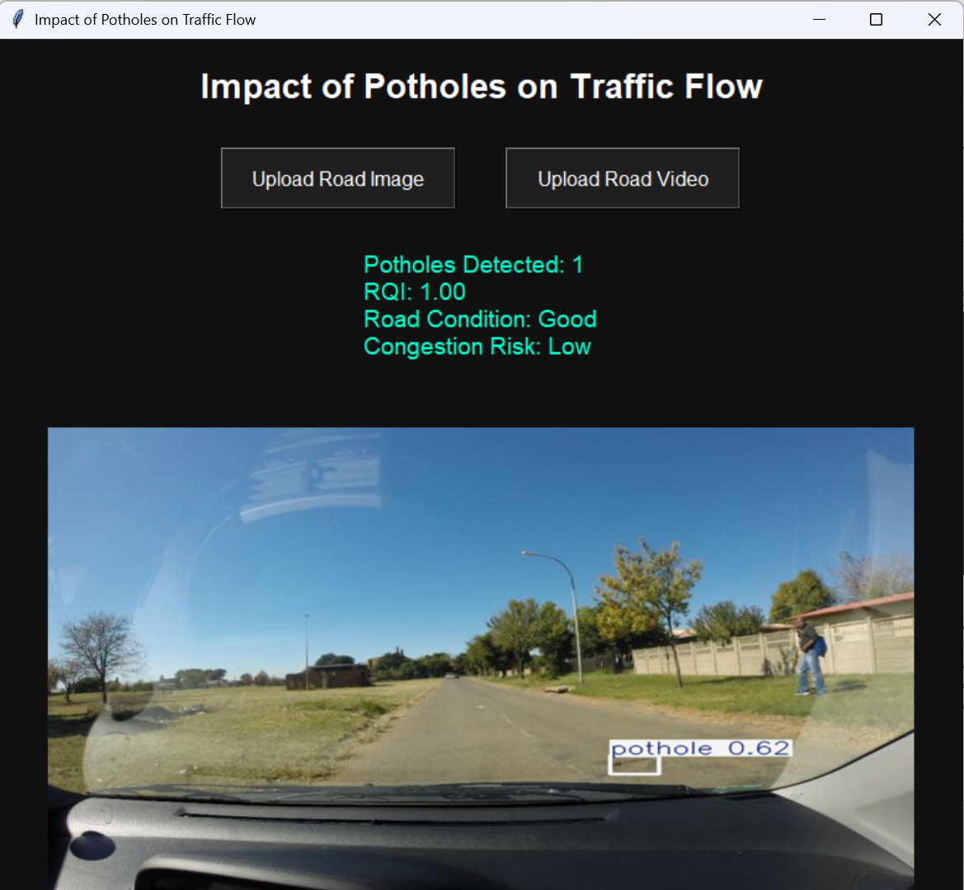

11. Advantages
- Automated road inspection

- Real-time traffic impact analysis
- Cost-effective solution
- Can be integrated with smart city systems
- Scalable for large-scale deployment
12. Limitations
- Accuracy depends on trained model quality
- Works best in clear lighting conditions
- Does not account for traffic density directly
- Weather conditions may affect detection
13. Future Scope
- Integration with live CCTV feeds
- GPS-based road mapping
- Cloud-based monitoring system
- Automatic government reporting
- Mobile application version
- Integration with smart traffic signals
14. Conclusion
This project successfully demonstrates how artificial intelligence and computer vision can be applied to analyze road conditions and their impact on traffic flow. By detecting potholes and calculating Road Quality Index (RQI), the system estimates congestion risk and recommends safe speeds. This AI-based solution has strong potential for smart city infrastructure, automated road inspection, and intelligent traffic management systems.
15. References
- YOLOv8 Documentation – Ultralytics
- OpenCV Documentation
- Python Tkinter Documentation
16. Pre-requisites
- Python 3.10 or higher
- Jupyter Notebook ( for model training and analysis )
- Terminal ( for GUI execution )
- Ultralytics (YOLOv8 framework)
- opencv-python
- pillow (PIL)
- tkinter (built-in with Python)
17. Steps to Run
Step1- open the cmd terminal.
Step2- type “python app.py”.
Step3- a dashboard will appear on screen.
Step4- upload image or video to analyze road conditions.
18. Dataset Link
https://universe.roboflow.com/indian-institute-of-technology-madras-xamot/pothole-detection-huf2x/dataset/2

